Project Design Phase-II
Technology Stack (Architecture & Stack)

Date | 13 July 2026
Team ID | -
Project Name | Book Store
Maximum Marks | 4 Marks

Technical Architecture:
The Deliverable shall include the architectural diagram as below and the information as per the table1 & table 2
Example: MERN Stack Based Online Book Store System Architecture
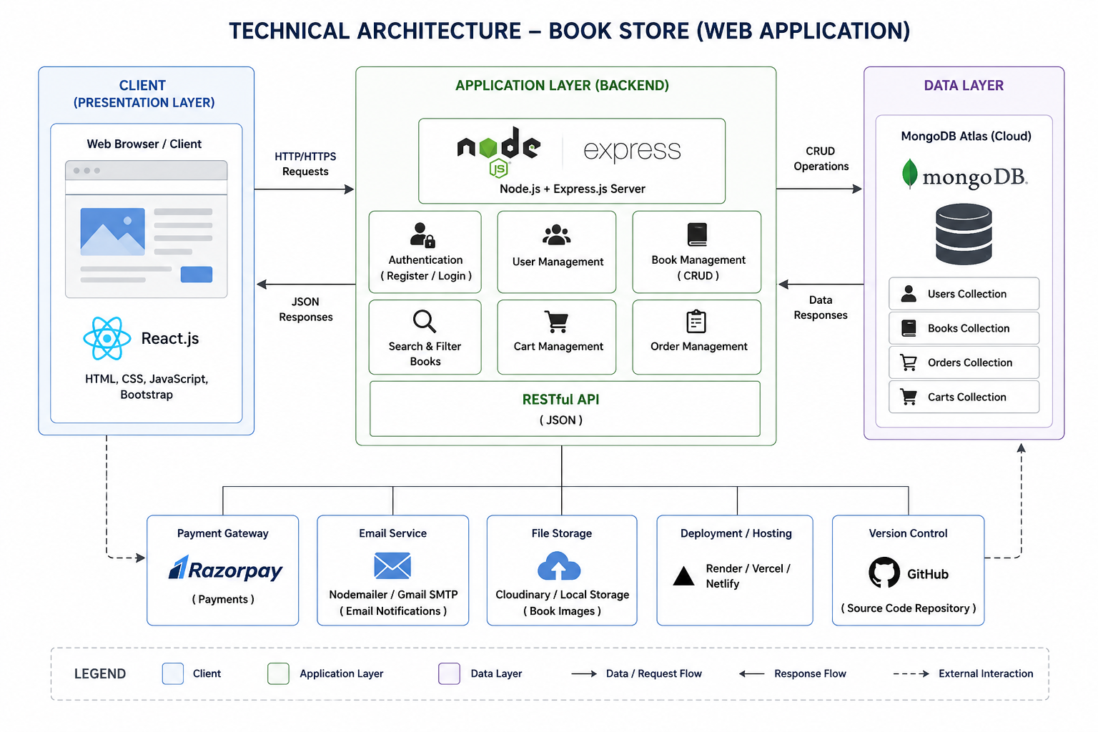

Table-1 : Components & Technologies:
S.No | Component | Description | Technology
 | User Interface | Web interface for users and admin | React.js, HTML5, CSS3, JavaScript, Bootstrap .
 | Application Logic-1 | User authentication and authorization | Node.js, Express.js, JWT
 | Application Logic-2 | Book search, cart and order processing | Node.js, Express.js
 | Application Logic-3 | Admin dashboard and book management | Node.js, Express.js
 | Database | Stores users, books, carts and orders . | MongoDB
 | Cloud Database | Cloud-hosted MongoDB database | MongoDB Atlas
 | File Storage | Stores book cover images | Local Storage / Cloudinary
 | External API-1 | Payment processing | Razorpay API
 | External API-2 | Email notifications | Nodemailer (Gmail SMTP)
 | Machine Learning Model | Not Applicable l | N/A .
 | Infrastructure (Server / Cloud) | Application deployment : | Localhost, Render/Vercel, MongoDB Atlas

Table-2: Application Characteristics:
S.No | Characteristics | Description | Technology
 | Open-Source Frameworks | Frameworks used for application development | React.js, Node.js, Express.js, MongoDB
 | Security Implementations | Secure login, password encryption, authentication | JWT, bcrypt, HTTPS, OWASP practices
 | Scalable Architecture | Three-tier architecture supporting future expansion | MERN Stack
 | Availability | Accessible through the internet with high availability | MongoDB Atlas, Render/Vercel
 | Performance | Fast search, optimized database queries and caching | MongoDB Indexing, Express.js

References
- https://react.dev/
- https://expressjs.com/
- https://nodejs.org/
- https://www.mongodb.com/
- https://www.mongodb.com/atlas

